RESUME

HARIHARAN.A

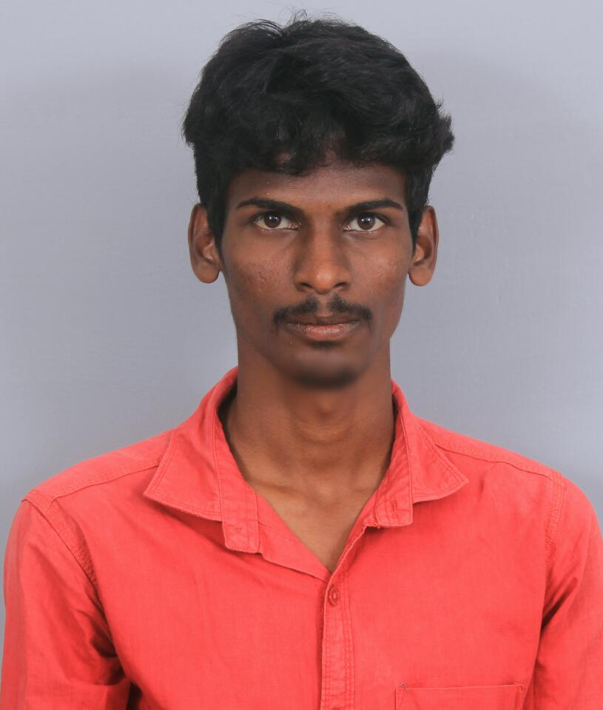

Address for Communication:
16/374-A, Balaji Nagar,
Union Bank Backside,
Karumathampatti,
Coimbatore641659
Phone: +91-7402157480
Email:hariharan5794@gmail.com

OBJECTIVE

Reach the target with sincerity and dedication to surpass at any work. Take special interest and doing things beyond routine duties in my work.

ACADEMIC RECORD

Course | Institution | Board/  University | Year of  Completion | Marks %  / CGPA
B.E Mechanical  XII  X | Kathir College of Engineering.  Literacy Mission Matriculation Hr.Sec School.  Literacy Mission Matriculation Hr.Sec School. | Anna University  Matriculation  Matriculation | 2016  2012  2010 | 62.58%  76%

TECHNICAL DETAILS

- AUTOCAD

- PRO-E

- SOLID WORKS

FIELD OF INTEREST

- ENGINEERING MECHANICS

- DESIGN OF MACHINARY

PROJECT

- MINI PROJECT

Title: Semiautomatic Air Filtering Cleaning Machines

Description: Helps to clean Air Filter automatically by placing it in Semiautomatic Air Filtering Cleaning Machine.

- INTERNSHIP

Undergoing project titled on “HORN DIVISON” in Roots Industry India Ltd., Coimbatore.

CO-CURRICULAR ACTIVITES

- Implant Training

Undergone Implant Training on Automobile Spare Parts Functions in CTC Dippo at Karumathampatti.

- Position and Responsibility

Member of IWS – Indian Welding Society

- Activities

Participated Park Inter-college Event HUMMITY TUMMITY.

PAPER PRESENTATION:

Presented paper titled on “Ball Piston Engine” at TECHBASH 2015 at Sri Shakthi Institute of Engineering & Technology and won first place.

PERSONAL SKILLS:

- Ability to deal with people diplomatically.

- Willingness to learn.

- Team facilitator & hard worker

HOBBIES

- Reading Articles about Automobiles.

- Dismantling and Mantling Automobile Parts.

- Playing Carom.

PERSONAL DETAILS

Name : Hariharan.A
Father’s Name : Mr.Ayyasamy.R
Date of birth : 05-07-1994
Gender : Male
Marital Status : Single
Nationality : Indian
Languages known : English, Tamil (To Speak, Read & write)

DECLARATION

I hereby declare that the details furnished above are true to the best of my knowledge and belief.

PLACE: COIMBATORE SIGNATURE

DATE : Hariharan.A

